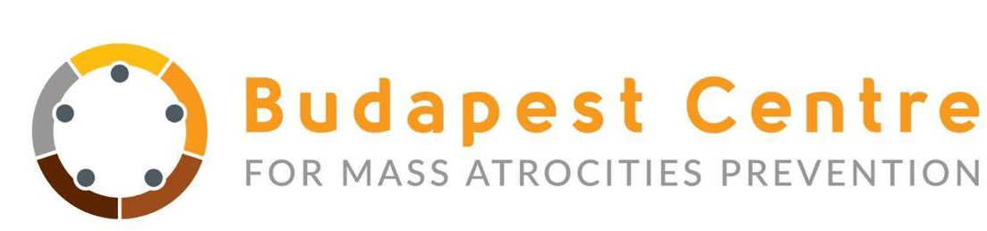

Words are Stones
- Focus Group Meetings -

Working in partnership with organizations across several European countries, the Budapest Centre for Mass Atrocities Prevention is participating in the EU Commission funded project: Words are Stones. This project aims to combat online hate speech based upon racism and discrimination.
We are reaching out to you in order to invite you to one of our focus group meetings which will be the opening stage of the initiative. Focus groups will be organized in English with around 10 participants in each. Participants will be journalists, media professionals, young people and students, anti-discrimination experts/professionals, social media managers/strategists, bloggers, teachers, members of organizations working in the field of migration and members of the LGBT community. The aim is to develop a rounded and focused perspective on the issues faced, and to gather information about the grassroots perception of hate speech and its digital diffusion.
We request all candidates to send the filled in form and their CVs as well to Ms. Francesca Cocomero (francesca.cocomero@budapestcentre.eu) by Wednesday, 7 February 2018.
*Required

Name *

Email address (for contacting purposes only) *

Categories to apply for (multiple can be selected): *

Mark selected with “x”

Journalists/media
Young people and students (aged between 14-25)
Anti-discrimination experts/professionals
Social media managers/strategists
Bloggers
Teachers
Members of organizations working in the field of migration
Members of the LGBT community

